

|  |  |  |
| --- | --- | --- |
| **MATHEMATICS DEPARTMENT** | |  |
| **Course:** **A2MAA** | |
| **Topic Title**: **Investigation 3 – Univariate data analysis** | |
| Student Name:_____________________________________ | Date: __________2016 | | |
| Special Instructions: Calculators allowed, No Notes allowed. | Time Allowed: 50 mins | | |
|  | Marks: / 29 | | |

**In-class investigation**

**Question 1 (9 marks)**

Four students have missed Test 5 and the teacher needs to estimate marks for these students. She decides to base the mark on the students’ earlier results and wants each test to have the same weighting. The teacher calculates as follows for each student in the class:

1. Each of the Tests 1 to 4 is given a mark out of 25.
2. These marks are then added to create a combined mark out of 100 for Tests 1 to 4. The student mean and the standard deviation of these combined marks are also calculated.

For the combined marks for Tests 1 to 4, the mean is 65.4% and the standard deviation is 8.2%

For Test 5, the mean is 73.2% and the standard deviation is 3.5%

*As an estimate for Test 5, the missing students will receive the class mean for Test 5, plus 3.5% times their number of standard deviations above the mean of the previous four tests. This number is subtracted if they were below the mean.*

Example: Sol’s combined mark was 2 standard deviations above the mean of the combined marks. Sol’s estimate mark is 73.2% + 2 x 3.5% = 80.2%

(a) Why is each of the tests (1 to 4) given a mark out of 25? (1)

(b) Chas’ combined mark was 1 standard deviation above the mean of the combined marks. His estimate mark for Test 5 was 76.7%.

Show how this is a correct estimate for Chas. (1)

(c) Lou’s combined mark was 2.5 standard deviations below the mean of the combined marks. Calculate his estimate mark for Test 5. (2)

(d) For Tests 1 to 4 Sam had the same mean as the class. (2)

Should he be given 73.2% as an estimate for Test 5? Justify your decision.

(e) Fred had a mean of 72% for Tests 1 to 4. Show how the estimate mark for Fred should be calculated. (3)

**Question 2 (10 marks)**

**Share dividends (cents per share)**

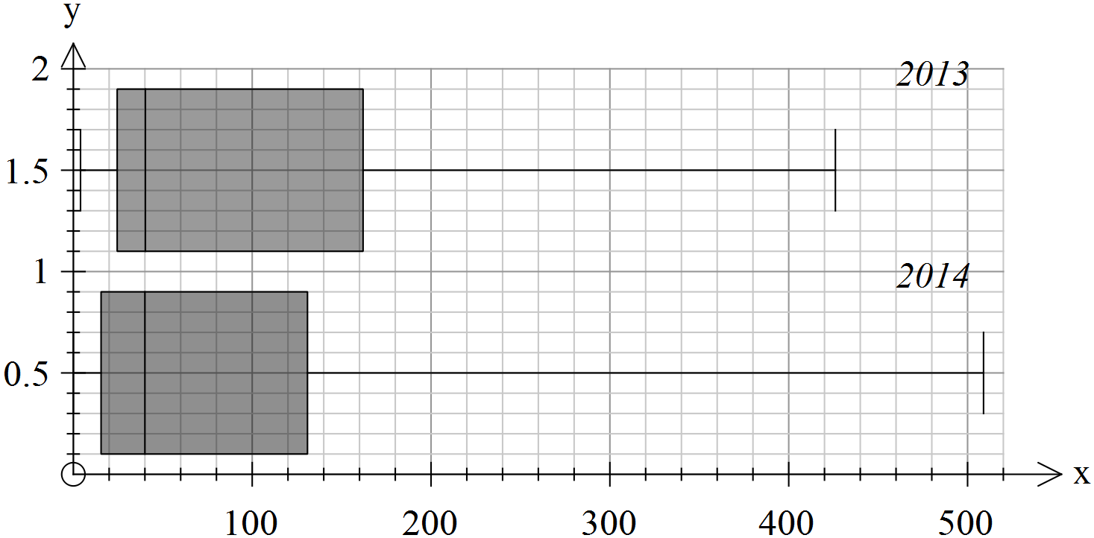

Sam’s mean for the first four tests

The box plots show the annual dividends (cents per share) for 25 companies in 2013 and 2014. The same companies are represented in each year.

For each of the statements below, state whether it is true, false or cannot be determined. Justify your conclusion by referring to evidence (including data where possible) from the box plots.

(a) The median dividend is the same for both years. (2)

(b) At least 75% of the dividends in 2013 were greater than $1 per share. (2)

(c) At least half of the dividends in 2014 were greater than $1 per share. (2)

(d) The maximum dividend in 2014 is greater than the maximum dividend in 2013. (2)

(e) There were more companies with dividends over 20c in 2014 than there were in 2013. (2)

**Question 3 (10 marks)**

The scores achieved on a particular test of intelligence conform to a normal distribution with a mean of 100 and a standard deviation of 15.

The table below shows the probability of a person achieving a score of intelligence within a specific range of values or outside this range.

|  |  |  |
| --- | --- | --- |
| Range of scores | Probability of being in that range | Probability of being outside that range |
| From 85 to 115 (100-15 to 100+15) | 0.68268949 | 0.31731051 |
| From 77.5 to 122.5 | 0.86638560 |  |
| From 70 to 130 | 0.95449974 | 0.04550026 |
| From 62.5 to 137.5 | 0.98758067 | 0.01241933 |
| From 55 to 145 |  |  |
| From 47.5 to 152.5 | 0.99953474 | 0.00046526 |
| From 40 to 160 |  | 0.00006334 |

(a) Complete the table by entering the probabilities correct to 8 decimal places. (4)

(b) From a population of 100 people selected at random, how many would you expect to score in the range of 85 to 115? (1)

(c) From a population of 10 000 people selected at random, how many would you expect to have a score higher than 152.5? (2)

(d) To expect to locate three people each with a score over 160, what is the minimum number of people (to the nearest thousand) that you would need to sample? (2)

(e) For every *n* people you can expect to find 1 with a score outside the range of 70 to 130. Determine *n.* (1)

**End of questions**